Additional Resources for Clinicians

VA Life-Sustaining Treatment Decisions Initiative – Supports patient-centered care for seriously ill patients by promoting new practices for eliciting, documenting, and honoring patients’ values, goals, and preferences. A wide range of tools and resources are available:
LSTDI Overview: vaww.ethics.va.gov/LST.asp
LSTDI Implementation: vaww.ethics.va.gov/LST/ImplementationResources.asp
LSTDI Resources for Clinical Staff Caring for High-Risk Patients: vaww.ethics.va.gov/LST/ClinicalStaffResources.asp
EPEC - Education in Palliative and End of Life Care and EPEC for Veterans – Comprehensive, consensus-based, and end-user friendly set of materials that can be used to educate all health care professionals in the essential clinical competencies of palliative care, including those related to conducting goals of care conversations. The EPEC for Veterans program is a comprehensive adaptation of the EPEC Curriculum, with content addressing the specific needs of Veterans and their families. Materials can be found at http://epec.net/epec_veterans.php.
Vital Talk – Nonprofit organization with the mission of nurturing healthier communications between patients and clinicians, specializing in advanced communication skills courses for discussing serious illness and goals of care. Information can be found at www.vitaltalk.org.
Fast Facts – Concise, practical, peer-reviewed and evidence-based summaries on key palliative care topics important to clinicians and trainees caring for patients facing serious illness. Information can be found at http://www.mypcnow.org/fast-facts.
Patient Care Assessment System (PCAS) – VA Primary Care panel management tool that can be used to proactively identify high-risk patients, assign tasks to team members, and monitor completion of goals of care conversations and other services. The tool can be accessed by primary care team members at https://secure.vssc.med.va.gov/PCAS/.
Resources for Patients & Families

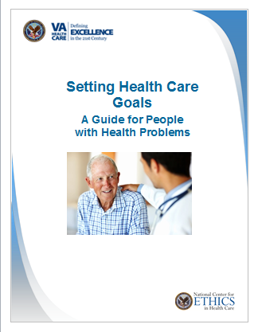
Setting Health Care Goals: A Guide for People with Health Problems – Handout for patients and surrogates that explains the nature and purpose of health care goals, and helps them prepare for a goals of care conversation. 8.5"x11”, large font, six pages. Electronic files available for download and a podcast version may be found at http://www.ethics.va.gov/LST/ClinicalStaffResources.asp.
Information about Life-Sustaining Treatments – Handouts for patients and surrogates that provide basic information about feeding tubes, dialysis, mechanical ventilation, and CPR. 8.5”x11”, large font. Electronic files available for download may be found at http://www.ethics.va.gov/LST/ClinicalStaffResources.asp.
- Copies of an informational booklet that includes both Setting Health Care Goals and Information about Life-Sustaining Treatments can be ordered by VA staff free of charge. Ordering information can be found at vaww.ethics.va.gov/LST/ClinicalStaffResources.asp.
- Prepare for Your Care – This web-based program uses audio and visual prompts in several languages to help users learn about advance care planning and document their wishes for care near the end of life. Users can save and print a document outlining their wishes to share with their health care team and family members. Available at http://www.prepareforyourcare.org.

- The Letter Project: What Matters Most – This program provides a template for writing a letter to one’s doctor and/or family about what matters most to a person in the last chapter of their life. The letters can be printed or emailed.
  - Version for Veterans available at http://www.paloalto.va.gov/letterproject.asp.
  - Version in several languages for use on mobile devices available through the Apple App Store. Search for “Stanford Letter Project.”

NOTE: Patients can attach copies of the “Prepare” and “Letter Project” documents to their VA Advance Directive form as indications of their preferences.

